NAME: AQSA TAUHEED (2303.KHI.DEG.011)

PAIRING WITH : Mohammad Hussam (2303.KHI.DEG.020)

& MAVIA ALAM KHAN (2303.KHI.DEG.017)

ASSIGNMENT NO : 4.5

Import os , redis and add environment

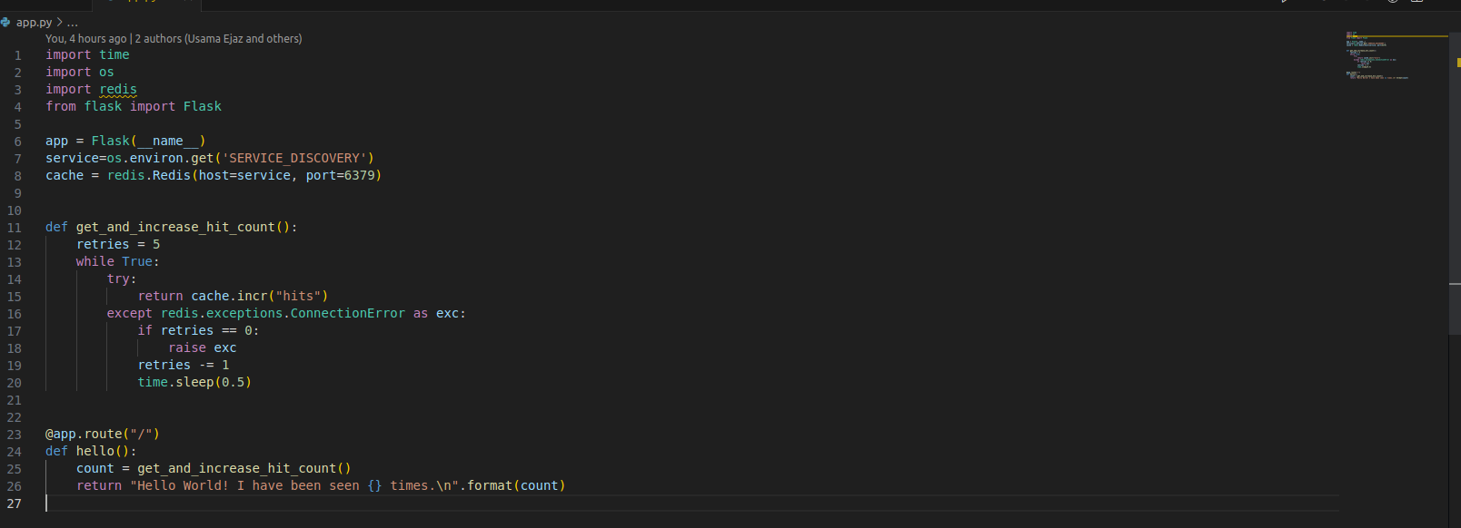

Add env to the docker file

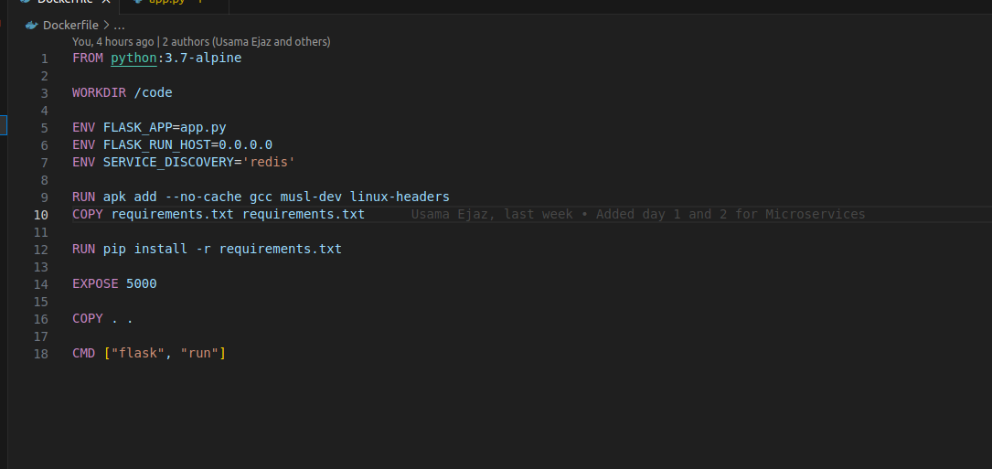

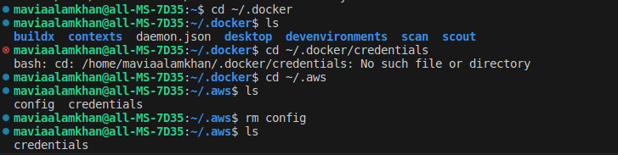



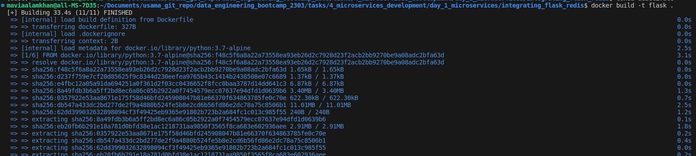

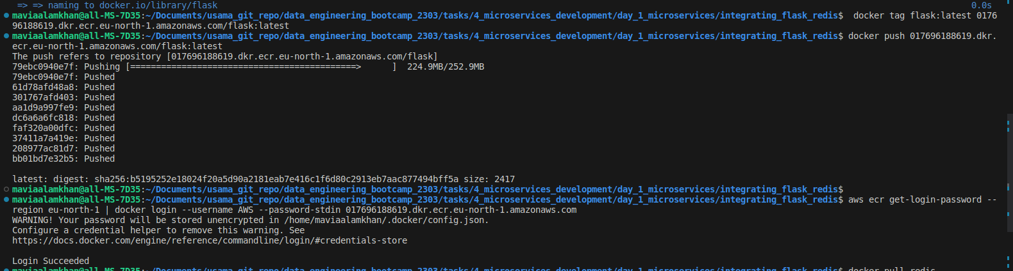

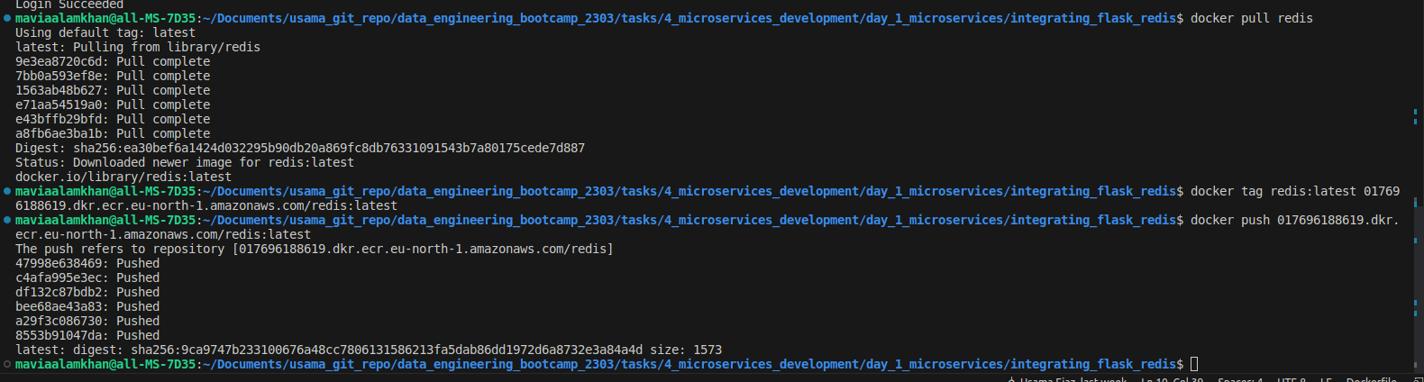

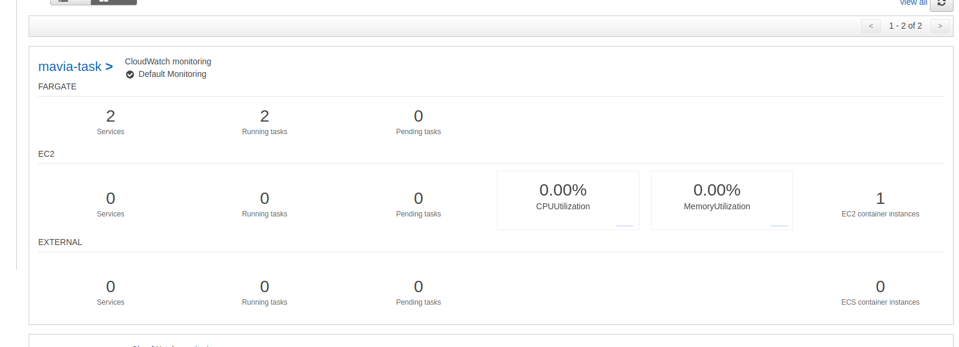

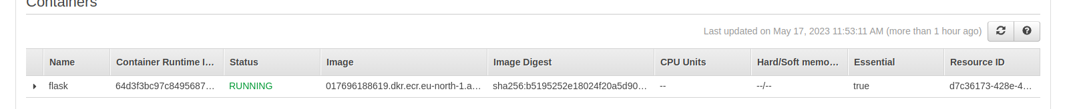

Creating namespace and services

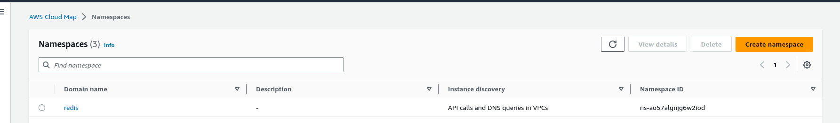

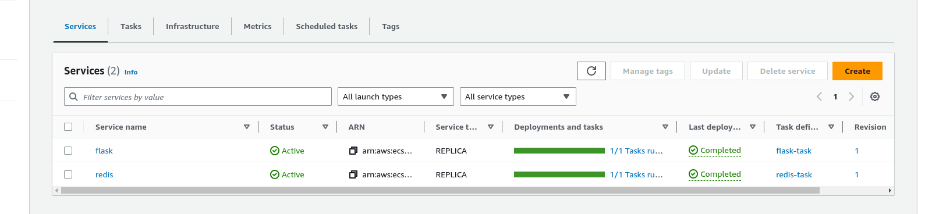

Copying the public ip

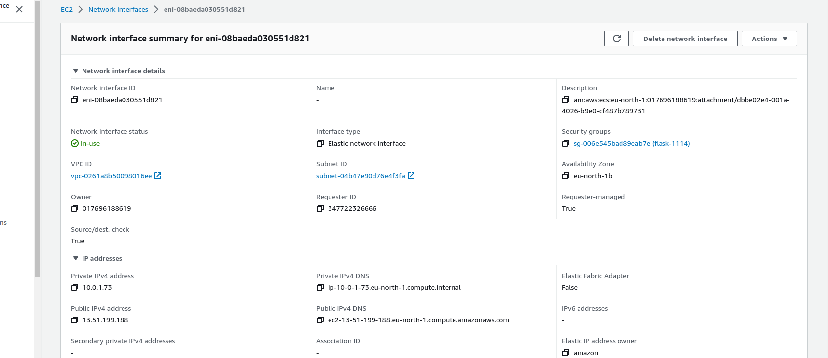

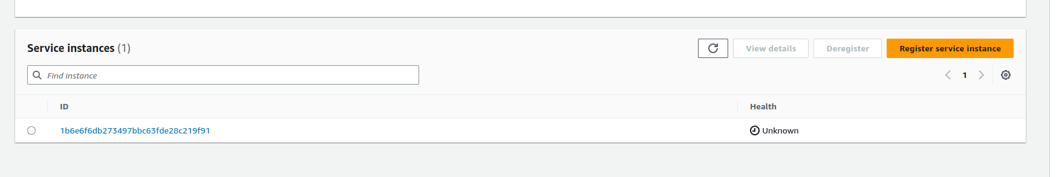

Pushing flask and redis images

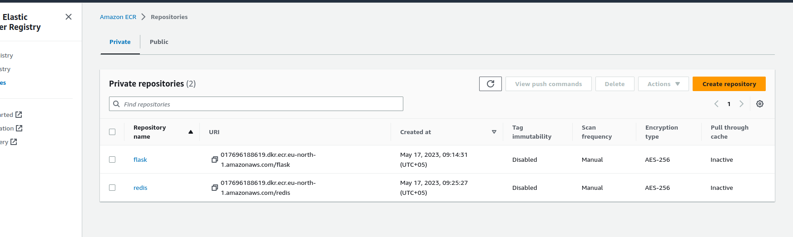

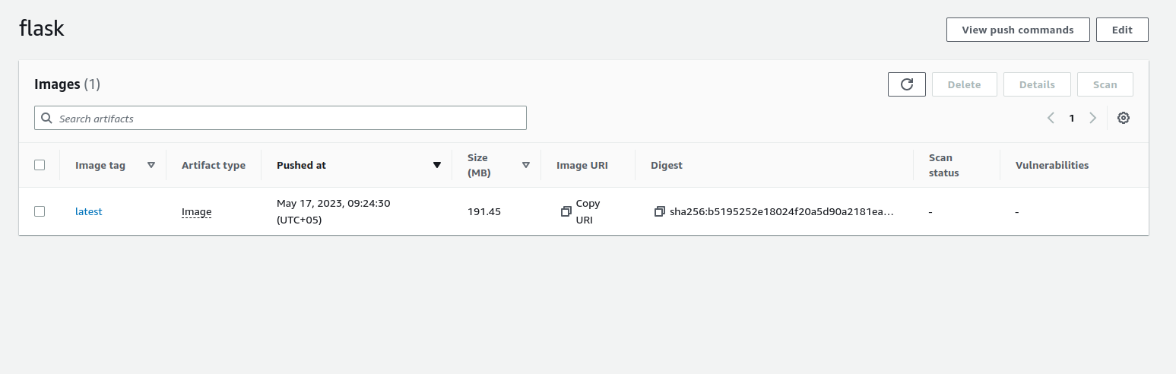

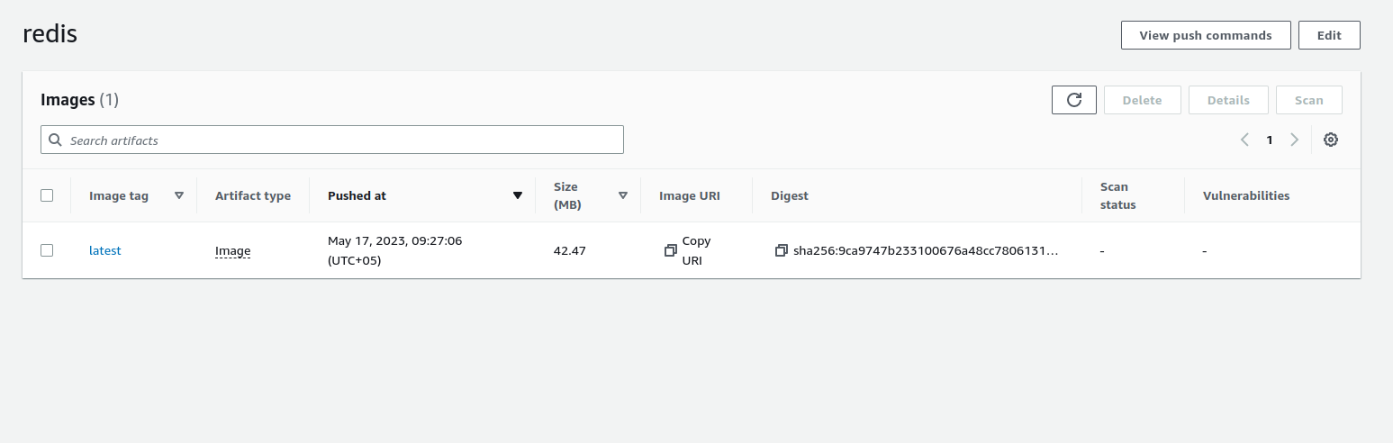

Output the result and checking deployment of 5000 port number

